Supplementary information: Worsham et al. 2024. Abiotic influences on subalpine conifer forest structure

May 13, 2024

## Supplementary tables

**Table S1.** Algorithms, parameters, and vectors of values applied on those parameters in ITD training and validation.

| I | Algorithm | Parameter | Description | Tested values |
| --- | --- | --- | --- | --- |
| 1 | Li (2012) | dt1 | Threshold 1. Refer to p. 79 in Li et al. (2012) | 0.5, 1.0, 1.5, 2.0 |
|  |  | dt2 | Threshold 2. Refer to p. 79 in Li et al. (2012) | 0.5, 1.0, 1.5, 2.0 |
|  |  | hmin | Minimum height threshold in m, below which a new tree cannot be initiated | 1.3 |
|  |  | R | Search radius. Refer to p. 79 in Li et al. (2012) | 0, 1, 2 |
|  |  | Zu | Height switch for dt1 and dt2. Use dt1 unless point height > Zu; then use dt2 | 14, 15, 16 |
| 2 | LMF-auto (Jean-Romain et al. in prep) | NA | LMF-auto is parameterless by design | NA |
| 3 | LMF fixed-window (Popescu and Wynne 2004) | ws | Window size: side length or diameter of the moving window used to detect the local maxima | The sequence 0.2:10.0 incrementing by 0.2 |
|  |  | shape | Shape of the window, either circular or square | circular, square |
|  |  | hmin | Minimum height threshold in m, below which a new tree cannot be initiated | 1.3 |
| 4 | LMF variable-window (Popescu and Wynne 2004) | b0 | First coefficient, β_0 on the function for computing variable-window size: w=β_0*-e^(-β_1 (Z-2)-1)+β_2 | 0.5, 1.0, 1.5, 2.0, 2.5 |
|  |  | b1 | Second coefficient β_1 on the variable window size function | 0.02, 0.04, 0.06, 0.08, 0.10, 0.12, 0.14, 0.16 |
|  |  | c0 | Third coefficient β_2 on the variable window size function | 1, 2, 3, 4, 5 |
|  |  | shape | Shape of the window, either circular or square | circular, square |
|  |  | hmin | Minimum height threshold in m, below which a new tree cannot be initiated | 1.3 |
| 5 | LayerStacking (Ayrey 2017) | start | the starting height above ground at which layer divisions begin | 0.5 |
|  |  | resolution | Resolution of the CHM | 0.5, 1 |
|  |  | window1 | window radius for the first local maximum filter for detecting tree tops | 1, 2, 3 |
|  |  | buffer | size of the buffer enforced around each point to create a polygonal cluster | 1, 2, 3 |
|  |  | hardwood | logical switch, where False adds weight to clusters to account for mid-canopy density in conifer stands | F |
|  |  | window2 | window radius for the second local maximum filter for detecting tree tops | 0.2, 0.4, 0.6, 0.8 |
|  |  | hmin | Minimum height threshold in m, below which a new tree cannot be initiated | 1.3 |
| 6 | MultiCHM (Eysn 2015) | resolution | Resolution of the CHM | 0.5, 1 |
|  |  | layer_thickness | The eliminating layer in the original paper is defined as a layer of `layer_thickness` m below the current CHM. Refer to Eysn 2015 p. 1728). | 0.25, 0.5 |
|  |  | dist_2d | 2D threshold for delineating a tree from local maximum. A tree is created if no other detected tree lies within this distance | 0.1, 0.25, 0.5, 1, 2 |
|  |  | dist_3d | 3D threshold for delineating a tree from local maximum. A tree is created if no other detected tree lies within this distance | 0.5, 1, 3, 5 |
| 7 | PTrees (Vega 2014) | k | Number of nearest neighbors to use in search. Refer to Vega (2014). | All forward and reverse permutations of the sequence: {5, 6, 7, 8, 10, 12, 15, 20, 25, 30, 40, 60, 80, 100} |
|  |  | hmin | Minimum height of a detected tree. Addition not in the original paper included to reduce oversegmentation. | 1.3 |
| 8 | Inverted watershed (Koch et al. 2006) | resolution | Resolution of the CHM | 0.5, 1, 1.5, 2 |
|  |  | th_tree | Minimum height threshold in m, below which a new tree cannot be initiated | 1.3 |
|  |  | subcircle_size | radius of circles used to rasterize the point cloud to CHM | 0.1, 0.2, 0.3, 0.4, 0.5, 0.6, 0.7, 0.8 |
|  |  | kernel_size | Size of kernel to smoothe CHM before applying watershed algorithm | 3, 5, 9, 15 |
|  |  | tolerance | Minimum Z distance between a tree candidate's highest point and the point where it contacts another tree. If Z distance < tolerance, the object is merged with its highest neighbor. | 1 |
|  |  | ext | Search radius in pixels for neighboring trees | 1 |

**Table S2.** Performance statistics for each parameter permutation used to force the LayerStacking individual tree detection (ITD) algorithm.

| Parameter set | N reference trees | N detected trees | Extraction rate | Match rate | Overall accuracy | Omission rate | Commission rate | RMS ~∆XY~ | RMS ~∆Z~ | RMS ~∆XYZ~ | Precision | Recall | F |
| --- | --- | --- | --- | --- | --- | --- | --- | --- | --- | --- | --- | --- | --- |
| 1 | 4,355 | 15,147 | 3.48 | 0.71 | 0.71 | 0.34 | 0.81 | 1.95 | 1.11 | 2.25 | 0.19 | 0.71 | 0.29 |
| 2 | 4,355 | 11,253 | 2.58 | 0.70 | 0.70 | 0.34 | 0.75 | 2.07 | 1.22 | 2.40 | 0.26 | 0.70 | 0.36 |
| 3 | 4,355 | 14,958 | 3.43 | 0.71 | 0.71 | 0.33 | 0.81 | 1.97 | 1.13 | 2.27 | 0.20 | 0.71 | 0.30 |
| 4 | 4,355 | 11,290 | 2.59 | 0.70 | 0.70 | 0.33 | 0.75 | 2.09 | 1.23 | 2.42 | 0.26 | 0.70 | 0.36 |
| 5 | 4,355 | 15,046 | 3.45 | 0.71 | 0.71 | 0.33 | 0.81 | 1.93 | 1.13 | 2.24 | 0.20 | 0.71 | 0.30 |
| 6 | 4,355 | 11,047 | 2.54 | 0.69 | 0.69 | 0.35 | 0.75 | 2.08 | 1.20 | 2.40 | 0.26 | 0.69 | 0.36 |
| 7 | 4,355 | 4,196 | 0.96 | 0.55 | 0.55 | 0.49 | 0.51 | 2.45 | 1.46 | 2.85 | 0.53 | 0.55 | 0.51 |
| 8 | 4,355 | 3,858 | 0.89 | 0.52 | 0.52 | 0.50 | 0.48 | 2.51 | 1.45 | 2.90 | 0.55 | 0.52 | 0.51 |
| 9 | 4,355 | 4,186 | 0.96 | 0.54 | 0.54 | 0.49 | 0.51 | 2.50 | 1.44 | 2.88 | 0.52 | 0.54 | 0.50 |
| 10 | 4,355 | 3,830 | 0.88 | 0.52 | 0.52 | 0.51 | 0.48 | 2.54 | 1.44 | 2.92 | 0.55 | 0.52 | 0.51 |
| 11 | 4,355 | 4,153 | 0.95 | 0.54 | 0.54 | 0.49 | 0.51 | 2.49 | 1.44 | 2.88 | 0.52 | 0.54 | 0.50 |
| 12 | 4,355 | 3,848 | 0.88 | 0.51 | 0.51 | 0.51 | 0.49 | 2.53 | 1.43 | 2.90 | 0.54 | 0.51 | 0.50 |
| 13 | 4,355 | 1,991 | 0.46 | 0.34 | 0.34 | 0.67 | 0.36 | 2.67 | 1.45 | 3.04 | 0.70 | 0.34 | 0.44 |
| 14 | 4,355 | 1,845 | 0.42 | 0.32 | 0.32 | 0.70 | 0.37 | 2.72 | 1.46 | 3.08 | 0.69 | 0.32 | 0.41 |
| 15 | 4,355 | 1,996 | 0.46 | 0.33 | 0.33 | 0.68 | 0.38 | 2.66 | 1.47 | 3.04 | 0.68 | 0.33 | 0.43 |
| 16 | 4,355 | 1,777 | 0.41 | 0.32 | 0.32 | 0.70 | 0.35 | 2.76 | 1.50 | 3.14 | 0.71 | 0.32 | 0.42 |
| 17 | 4,355 | 1,999 | 0.46 | 0.34 | 0.34 | 0.67 | 0.37 | 2.67 | 1.44 | 3.03 | 0.68 | 0.34 | 0.44 |
| 18 | 4,355 | 1,785 | 0.41 | 0.31 | 0.31 | 0.70 | 0.36 | 2.68 | 1.49 | 3.06 | 0.70 | 0.31 | 0.41 |
| 19 | 4,355 | 5,259 | 1.21 | 0.42 | 0.42 | 0.64 | 0.60 | 2.46 | 1.34 | 2.80 | 0.50 | 0.42 | 0.34 |
| 20 | 4,355 | 11,295 | 2.59 | 0.70 | 0.70 | 0.34 | 0.75 | 2.07 | 1.23 | 2.41 | 0.26 | 0.70 | 0.36 |
| 21 | 4,355 | 2,512 | 0.58 | 0.25 | 0.25 | 0.80 | 0.46 | 2.73 | 1.47 | 3.10 | 0.65 | 0.25 | 0.26 |
| 22 | 4,355 | 11,241 | 2.58 | 0.69 | 0.69 | 0.35 | 0.75 | 2.05 | 1.19 | 2.37 | 0.26 | 0.69 | 0.36 |
| 23 | 4,355 | 1,802 | 0.41 | 0.20 | 0.20 | 0.82 | 0.45 | 2.72 | 1.48 | 3.10 | 0.64 | 0.20 | 0.26 |
| 24 | 4,355 | 11,210 | 2.57 | 0.70 | 0.70 | 0.35 | 0.75 | 2.08 | 1.20 | 2.40 | 0.26 | 0.70 | 0.36 |
| 25 | 4,355 | 1,406 | 0.32 | 0.26 | 0.26 | 0.79 | 0.35 | 2.75 | 1.49 | 3.13 | 0.73 | 0.26 | 0.31 |
| 26 | 4,355 | 3,844 | 0.88 | 0.51 | 0.51 | 0.51 | 0.48 | 2.50 | 1.43 | 2.89 | 0.55 | 0.51 | 0.51 |
| 27 | 4,355 | 804 | 0.18 | 0.15 | 0.15 | 0.87 | 0.31 | 2.86 | 1.53 | 3.25 | 0.78 | 0.15 | 0.20 |
| 28 | 4,355 | 3,858 | 0.89 | 0.52 | 0.52 | 0.50 | 0.48 | 2.50 | 1.41 | 2.87 | 0.55 | 0.52 | 0.51 |
| 29 | 4,355 | 626 | 0.14 | 0.11 | 0.11 | 0.89 | 0.31 | 2.89 | 1.51 | 3.26 | 0.79 | 0.11 | 0.19 |
| 30 | 4,355 | 3,827 | 0.88 | 0.51 | 0.51 | 0.51 | 0.48 | 2.51 | 1.44 | 2.89 | 0.55 | 0.51 | 0.51 |
| 31 | 4,355 | 638 | 0.15 | 0.14 | 0.14 | 0.89 | 0.32 | 2.82 | 1.64 | 3.26 | 0.76 | 0.14 | 0.20 |
| 32 | 4,355 | 1,810 | 0.42 | 0.30 | 0.30 | 0.70 | 0.37 | 2.65 | 1.50 | 3.04 | 0.68 | 0.30 | 0.40 |
| 33 | 4,355 | 463 | 0.11 | 0.10 | 0.10 | 0.91 | 0.29 | 2.87 | 1.60 | 3.29 | 0.80 | 0.10 | 0.15 |
| 34 | 4,355 | 1,815 | 0.42 | 0.32 | 0.32 | 0.69 | 0.35 | 2.68 | 1.48 | 3.06 | 0.71 | 0.32 | 0.42 |
| 35 | 4,355 | 403 | 0.09 | 0.08 | 0.08 | 0.92 | 0.28 | 2.92 | 1.57 | 3.32 | 0.79 | 0.08 | 0.14 |
| 36 | 4,355 | 1,780 | 0.41 | 0.30 | 0.30 | 0.71 | 0.37 | 2.71 | 1.48 | 3.08 | 0.68 | 0.30 | 0.40 |
| 37 | 4,355 | 4,941 | 1.13 | 0.42 | 0.42 | 0.65 | 0.58 | 2.52 | 1.41 | 2.88 | 0.52 | 0.42 | 0.34 |
| 38 | 4,355 | 4,018 | 0.92 | 0.41 | 0.41 | 0.66 | 0.53 | 2.54 | 1.48 | 2.94 | 0.54 | 0.41 | 0.36 |
| 39 | 4,355 | 2,284 | 0.52 | 0.24 | 0.24 | 0.82 | 0.45 | 2.73 | 1.57 | 3.15 | 0.67 | 0.24 | 0.24 |
| 40 | 4,355 | 3,185 | 0.73 | 0.33 | 0.33 | 0.73 | 0.48 | 2.64 | 1.57 | 3.08 | 0.61 | 0.33 | 0.32 |
| 41 | 4,355 | 1,584 | 0.36 | 0.18 | 0.18 | 0.83 | 0.43 | 2.77 | 1.58 | 3.19 | 0.67 | 0.18 | 0.25 |
| 42 | 4,355 | 2,488 | 0.57 | 0.28 | 0.28 | 0.77 | 0.46 | 2.65 | 1.57 | 3.08 | 0.63 | 0.28 | 0.30 |
| 43 | 4,355 | 1,334 | 0.31 | 0.23 | 0.23 | 0.81 | 0.37 | 2.72 | 1.53 | 3.12 | 0.71 | 0.23 | 0.29 |
| 44 | 4,355 | 1,434 | 0.33 | 0.24 | 0.24 | 0.80 | 0.36 | 2.72 | 1.57 | 3.14 | 0.72 | 0.24 | 0.31 |
| 45 | 4,355 | 754 | 0.17 | 0.15 | 0.15 | 0.88 | 0.31 | 2.84 | 1.63 | 3.27 | 0.79 | 0.15 | 0.20 |
| 46 | 4,355 | 1,208 | 0.28 | 0.21 | 0.21 | 0.83 | 0.33 | 2.74 | 1.61 | 3.18 | 0.74 | 0.21 | 0.28 |
| 47 | 4,355 | 585 | 0.13 | 0.11 | 0.11 | 0.90 | 0.31 | 2.92 | 1.62 | 3.34 | 0.79 | 0.11 | 0.18 |
| 48 | 4,355 | 981 | 0.23 | 0.18 | 0.18 | 0.85 | 0.31 | 2.80 | 1.64 | 3.25 | 0.76 | 0.18 | 0.26 |
| 49 | 4,355 | 598 | 0.14 | 0.12 | 0.12 | 0.90 | 0.35 | 2.77 | 1.59 | 3.20 | 0.74 | 0.12 | 0.18 |
| 50 | 4,355 | 703 | 0.16 | 0.14 | 0.14 | 0.87 | 0.30 | 2.84 | 1.62 | 3.27 | 0.80 | 0.14 | 0.21 |
| 51 | 4,355 | 455 | 0.10 | 0.09 | 0.09 | 0.92 | 0.30 | 2.89 | 1.67 | 3.34 | 0.80 | 0.09 | 0.14 |
| 52 | 4,355 | 652 | 0.15 | 0.13 | 0.13 | 0.89 | 0.30 | 2.80 | 1.68 | 3.26 | 0.78 | 0.13 | 0.20 |
| 53 | 4,355 | 396 | 0.09 | 0.08 | 0.08 | 0.92 | 0.28 | 2.93 | 1.70 | 3.39 | 0.80 | 0.08 | 0.14 |
| 54 | 4,355 | 562 | 0.13 | 0.11 | 0.11 | 0.90 | 0.29 | 2.85 | 1.75 | 3.34 | 0.78 | 0.11 | 0.18 |
| 55 | 4,355 | 4,120 | 0.95 | 0.39 | 0.39 | 0.69 | 0.56 | 2.56 | 1.40 | 2.92 | 0.55 | 0.39 | 0.33 |
| 56 | 4,355 | 3,445 | 0.79 | 0.37 | 0.37 | 0.69 | 0.51 | 2.56 | 1.53 | 2.98 | 0.57 | 0.37 | 0.35 |
| 57 | 4,355 | 1,849 | 0.42 | 0.21 | 0.21 | 0.84 | 0.42 | 2.78 | 1.58 | 3.20 | 0.69 | 0.21 | 0.21 |
| 58 | 4,355 | 2,843 | 0.65 | 0.30 | 0.30 | 0.76 | 0.47 | 2.64 | 1.59 | 3.09 | 0.63 | 0.30 | 0.30 |
| 59 | 4,355 | 1,166 | 0.27 | 0.14 | 0.14 | 0.87 | 0.41 | 2.78 | 1.62 | 3.22 | 0.70 | 0.14 | 0.20 |
| 60 | 4,355 | 2,203 | 0.51 | 0.26 | 0.26 | 0.78 | 0.44 | 2.70 | 1.63 | 3.16 | 0.66 | 0.26 | 0.29 |
| 61 | 4,355 | 1,109 | 0.25 | 0.21 | 0.21 | 0.83 | 0.35 | 2.74 | 1.56 | 3.15 | 0.74 | 0.21 | 0.27 |
| 62 | 4,355 | 1,247 | 0.29 | 0.22 | 0.22 | 0.81 | 0.34 | 2.77 | 1.55 | 3.18 | 0.73 | 0.22 | 0.29 |
| 63 | 4,355 | 656 | 0.15 | 0.14 | 0.14 | 0.89 | 0.30 | 2.86 | 1.65 | 3.30 | 0.79 | 0.14 | 0.18 |
| 64 | 4,355 | 1,106 | 0.25 | 0.20 | 0.20 | 0.84 | 0.33 | 2.80 | 1.62 | 3.24 | 0.75 | 0.20 | 0.26 |
| 65 | 4,355 | 515 | 0.12 | 0.10 | 0.10 | 0.91 | 0.31 | 2.91 | 1.71 | 3.37 | 0.79 | 0.10 | 0.16 |
| 66 | 4,355 | 894 | 0.21 | 0.16 | 0.16 | 0.86 | 0.31 | 2.84 | 1.70 | 3.31 | 0.75 | 0.16 | 0.24 |
| 67 | 4,355 | 563 | 0.13 | 0.12 | 0.12 | 0.90 | 0.32 | 2.82 | 1.59 | 3.24 | 0.76 | 0.12 | 0.18 |
| 68 | 4,355 | 634 | 0.15 | 0.13 | 0.13 | 0.89 | 0.29 | 2.90 | 1.63 | 3.33 | 0.80 | 0.13 | 0.19 |
| 69 | 4,355 | 432 | 0.10 | 0.09 | 0.09 | 0.92 | 0.29 | 2.92 | 1.72 | 3.39 | 0.81 | 0.09 | 0.14 |
| 70 | 4,355 | 590 | 0.14 | 0.11 | 0.11 | 0.90 | 0.30 | 2.93 | 1.72 | 3.40 | 0.79 | 0.11 | 0.18 |
| 71 | 4,355 | 374 | 0.09 | 0.08 | 0.08 | 0.92 | 0.26 | 2.92 | 1.74 | 3.40 | 0.81 | 0.08 | 0.14 |
| 72 | 4,355 | 521 | 0.12 | 0.11 | 0.11 | 0.90 | 0.27 | 2.96 | 1.74 | 3.43 | 0.80 | 0.11 | 0.18 |

**Table S3.** Basis functions (Call), initial k (k’) and estimated degrees of freedom (edf) for each variable and 2-way interaction in GAMs. k’ and edf values are reported separately for each response variable.

| Variable | Category | Call | Basal area | | Height 95P | | Height skew | | QMD | | Total density | | Fir density | | Spruce density | | Pine density | |
| --- | --- | --- | --- | --- | --- | --- | --- | --- | --- | --- | --- | --- | --- | --- | --- | --- | --- | --- |
| k' | edf | k' | edf | k' | edf | k' | edf | k' | edf | k' | edf | k' | edf | k' | edf |
| Heat load | Topography | s(heat_load) | 9 | 0.05 | 9 | 7.47 | 9 | 4.78 | 9 | 7.57 | 9 | 0.56 | 9 | 4.32 | 9 | 3.47 | 9 | 3.87 |
| Elevation | Topography | s(elevation) | 9 | 5.94 | 9 | 6.70 | 9 | 5.67 | 9 | 6.26 | 9 | 5.67 | 9 | 4.51 | 9 | 6.86 | 9 | 3.55 |
| TWI | Topography | s(twi) | 9 | 4.82 | 9 | 5.67 | 9 | 5.96 | 9 | 4.80 | 9 | 1.06 | 9 | 0.99 | 9 | 6.16 | 9 | 0.90 |
| TPI | Topography | s(tpi) | 9 | 5.22 | 9 | 5.30 | 9 | 4.87 | 9 | 4.92 | 9 | 2.32 | 9 | 2.11 | 9 | 3.46 | 9 | 4.27 |
| Curvature | Topography | s(curvature) | 9 | 1.01 | 9 | 3.22 | 9 | 1.41 | 9 | 3.16 | 9 | 3.88 | 9 | 3.34 | 9 | 3.31 | 9 | 3.37 |
| AWC | Soil | s(awc) | 9 | 7.08 | 9 | 7.58 | 9 | 8.00 | 9 | 7.78 | 9 | 7.16 | 9 | 0.02 | 9 | 6.68 | 9 | 4.64 |
| CEC | Soil | s(cec) | 9 | 7.57 | 9 | 8.01 | 9 | 8.15 | 9 | 7.85 | 9 | 6.47 | 9 | 5.92 | 9 | 5.59 | 9 | 2.66 |
| Silt content | Soil | s(silt) | 9 | 7.03 | 9 | 7.71 | 9 | 3.90 | 9 | 7.22 | 9 | 7.60 | 9 | 0.01 | 9 | 6.56 | 9 | 0.63 |
| ksat | Soil | s(ksat) | 9 | 5.93 | 9 | 6.08 | 9 | 1.58 | 9 | 6.75 | 9 | 4.36 | 9 | 0.00 | 9 | 2.01 | 9 | 5.50 |
| pH | Soil | s(ph) | 9 | 7.52 | 9 | 7.46 | 9 | 7.33 | 9 | 7.67 | 9 | 6.36 | 9 | 0.71 | 9 | 0.79 | 9 | 0.01 |
| Organic matter | Soil | s(om) | 9 | 6.89 | 9 | 6.56 | 9 | 8.54 | 9 | 8.13 | 9 | 7.22 | 9 | 5.94 | 9 | 5.15 | 9 | 5.80 |
| SWE | Climate | s(swe) | 9 | 8.35 | 9 | 7.27 | 9 | 8.43 | 9 | 7.73 | 9 | 8.74 | 9 | 5.99 | 9 | 6.89 | 9 | 7.40 |
| ΔSWE | Climate | s(delta_swe) | 9 | 7.00 | 9 | 7.28 | 9 | 1.00 | 9 | 5.80 | 9 | 7.47 | 9 | 1.00 | 9 | 4.37 | 9 | 1.33 |
| CWD | Climate | s(cwd) | 9 | 5.01 | 9 | 5.63 | 9 | 3.18 | 9 | 5.54 | 9 | 6.82 | 9 | 0.84 | 9 | 5.48 | 9 | 6.27 |
| AET | Climate | s(aet) | 9 | 7.60 | 9 | 7.31 | 9 | 6.36 | 9 | 7.47 | 9 | 7.13 | 9 | 0.00 | 9 | 4.74 | 9 | 0.02 |
| Geology | Geology | geology |  |  |  |  |  |  |  |  |  |  |  |  |  |  |  |  |
| Elevation : Heat load | Topography : Topography | ti(elevation,heat_load) | 16 | 6.45 | 16 | 6.01 | 16 | 13.04 | 16 | 6.09 | 16 | 7.64 | 16 | 9.34 | 16 | 8.23 | 16 | 5.28 |
| Elevation : TPI | Topography : Topography | ti(elevation,tpi) | 16 | 8.89 | 16 | 8.49 | 16 | 6.24 | 16 | 8.18 | 16 | 5.97 | 16 | 3.75 | 16 | 5.55 | 16 | 5.93 |
| Elevation : SWE | Topography : Climate | ti(elevation,swe) | 16 | 12.22 | 16 | 13.37 | 16 | 12.50 | 16 | 12.87 | 16 | 12.09 | 16 | 1.09 | 16 | 10.24 | 16 | 1.95 |
| Elevation : ΔSWE | Topography : Climate | ti(elevation,delta_swe) | 16 | 12.51 | 16 | 9.94 | 16 | 9.13 | 16 | 11.55 | 16 | 13.90 | 16 | 8.22 | 16 | 11.79 | 16 | 8.21 |
| Elevation : CWD | Topography : Climate | ti(elevation,cwd) | 16 | 12.29 | 16 | 12.80 | 16 | 10.05 | 16 | 12.14 | 16 | 11.80 | 16 | 11.19 | 16 | 10.18 | 16 | 10.39 |
| Elevation : AET | Topography : Climate | ti(elevation,aet) | 16 | 11.02 | 16 | 7.24 | 16 | 8.48 | 16 | 7.87 | 16 | 8.66 | 16 | 6.72 | 16 | 6.25 | 16 | 5.11 |
| TPI : SWE | Topography : Climate | ti(tpi,swe) | 16 | 10.23 | 16 | 10.22 | 16 | 10.02 | 16 | 9.58 | 16 | 7.99 | 16 | 7.08 | 16 | 8.38 | 16 | 8.14 |
| TPI : ΔSWE | Topography : Climate | ti(tpi,delta_swe) | 16 | 7.64 | 16 | 6.67 | 16 | 9.99 | 16 | 6.99 | 16 | 5.69 | 16 | 4.11 | 16 | 5.19 | 16 | 6.40 |
| TPI : CWD | Topography : Climate | ti(tpi,cwd) | 16 | 10.43 | 16 | 10.37 | 16 | 10.72 | 16 | 11.22 | 16 | 10.55 | 16 | 7.44 | 16 | 8.99 | 16 | 1.70 |
| TPI : AET | Topography : Climate | ti(tpi,aet) | 16 | 8.55 | 16 | 7.54 | 16 | 6.85 | 16 | 7.51 | 16 | 10.37 | 16 | 2.80 | 16 | 4.43 | 16 | 1.86 |
| AWC : SWE | Soil : Climate | ti(awc,swe) | 16 | 7.63 | 16 | 6.65 | 16 | 8.36 | 16 | 7.07 | 16 | 10.06 | 16 | 3.07 | 16 | 5.40 | 16 | 5.60 |
| AWC : ΔSWE | Soil : Climate | ti(awc,delta_swe) | 16 | 7.31 | 16 | 9.61 | 16 | 4.11 | 16 | 8.85 | 16 | 8.05 | 16 | 3.84 | 16 | 8.58 | 16 | 9.48 |
| AWC : AET | Soil : Climate | ti(awc,aet) | 16 | 13.31 | 16 | 8.85 | 16 | 10.14 | 16 | 11.01 | 16 | 11.97 | 16 | 0.03 | 16 | 8.90 | 16 | 5.07 |
| AWC : CWD | Soil : Climate | ti(awc,cwd) | 16 | 8.39 | 16 | 10.44 | 16 | 5.73 | 16 | 9.16 | 16 | 11.84 | 16 | 4.08 | 16 | 3.10 | 16 | 3.91 |
| Heat load : SWE | Topography : Climate | ti(heat_load,swe) | 16 | 8.23 | 16 | 10.71 | 16 | 8.81 | 16 | 11.25 | 16 | 9.48 | 16 | 2.33 | 16 | 8.93 | 16 | 3.87 |
| Heat load : ΔSWE | Topography : Climate | ti(heat_load,delta_swe) | 16 | 12.32 | 16 | 11.96 | 16 | 10.70 | 16 | 13.13 | 16 | 11.19 | 16 | 8.14 | 16 | 10.34 | 16 | 1.86 |
| Heat load : AWC | Topography : Soil | ti(heat_load,awc) | 16 | 10.91 | 16 | 11.10 | 16 | 12.10 | 16 | 11.72 | 16 | 9.26 | 16 | 8.30 | 16 | 0.22 | 16 | 3.96 |
| Heat load : AET | Topography : Climate | ti(heat_load,aet) | 16 | 10.99 | 16 | 10.87 | 16 | 11.15 | 16 | 12.25 | 16 | 9.09 | 16 | 2.22 | 16 | 6.32 | 16 | 6.50 |
| Heat load : CWD | Topography : Climate | ti(heat_load,cwd) | 16 | 9.57 | 16 | 9.27 | 16 | 10.69 | 16 | 9.67 | 16 | 11.95 | 16 | 2.05 | 16 | 1.75 | 16 | 4.96 |
| X : Y | Spatial | ti(x,y) | 16 | 14.12 | 16 | 13.67 | 16 | 14.12 | 16 | 14.01 | 16 | 13.80 | 16 | 12.19 | 16 | 2.35 | 16 | 11.64 |

**Table S4.** Optimal tuning parameters for GBMs under the full-factorial design.

| Response | N trees | Interaction depth | Shrinkage | Min obs. in node |
| --- | --- | --- | --- | --- |
| Basal area | 10,000 | 5 | 0.04 | 10 |
| Height 95P | 10,000 | 5 | 0.04 | 10 |
| Height skew | 6,000 | 5 | 0.02 | 10 |
| QMD | 10,000 | 5 | 0.04 | 10 |
| Total density | 10,000 | 5 | 0.04 | 10 |
| Fir density | 2,000 | 5 | 0.02 | 10 |
| Spruce density | 6,000 | 5 | 0.02 | 10 |
| Pine density | 6,000 | 5 | 0.02 | 10 |

## Supplementary figures

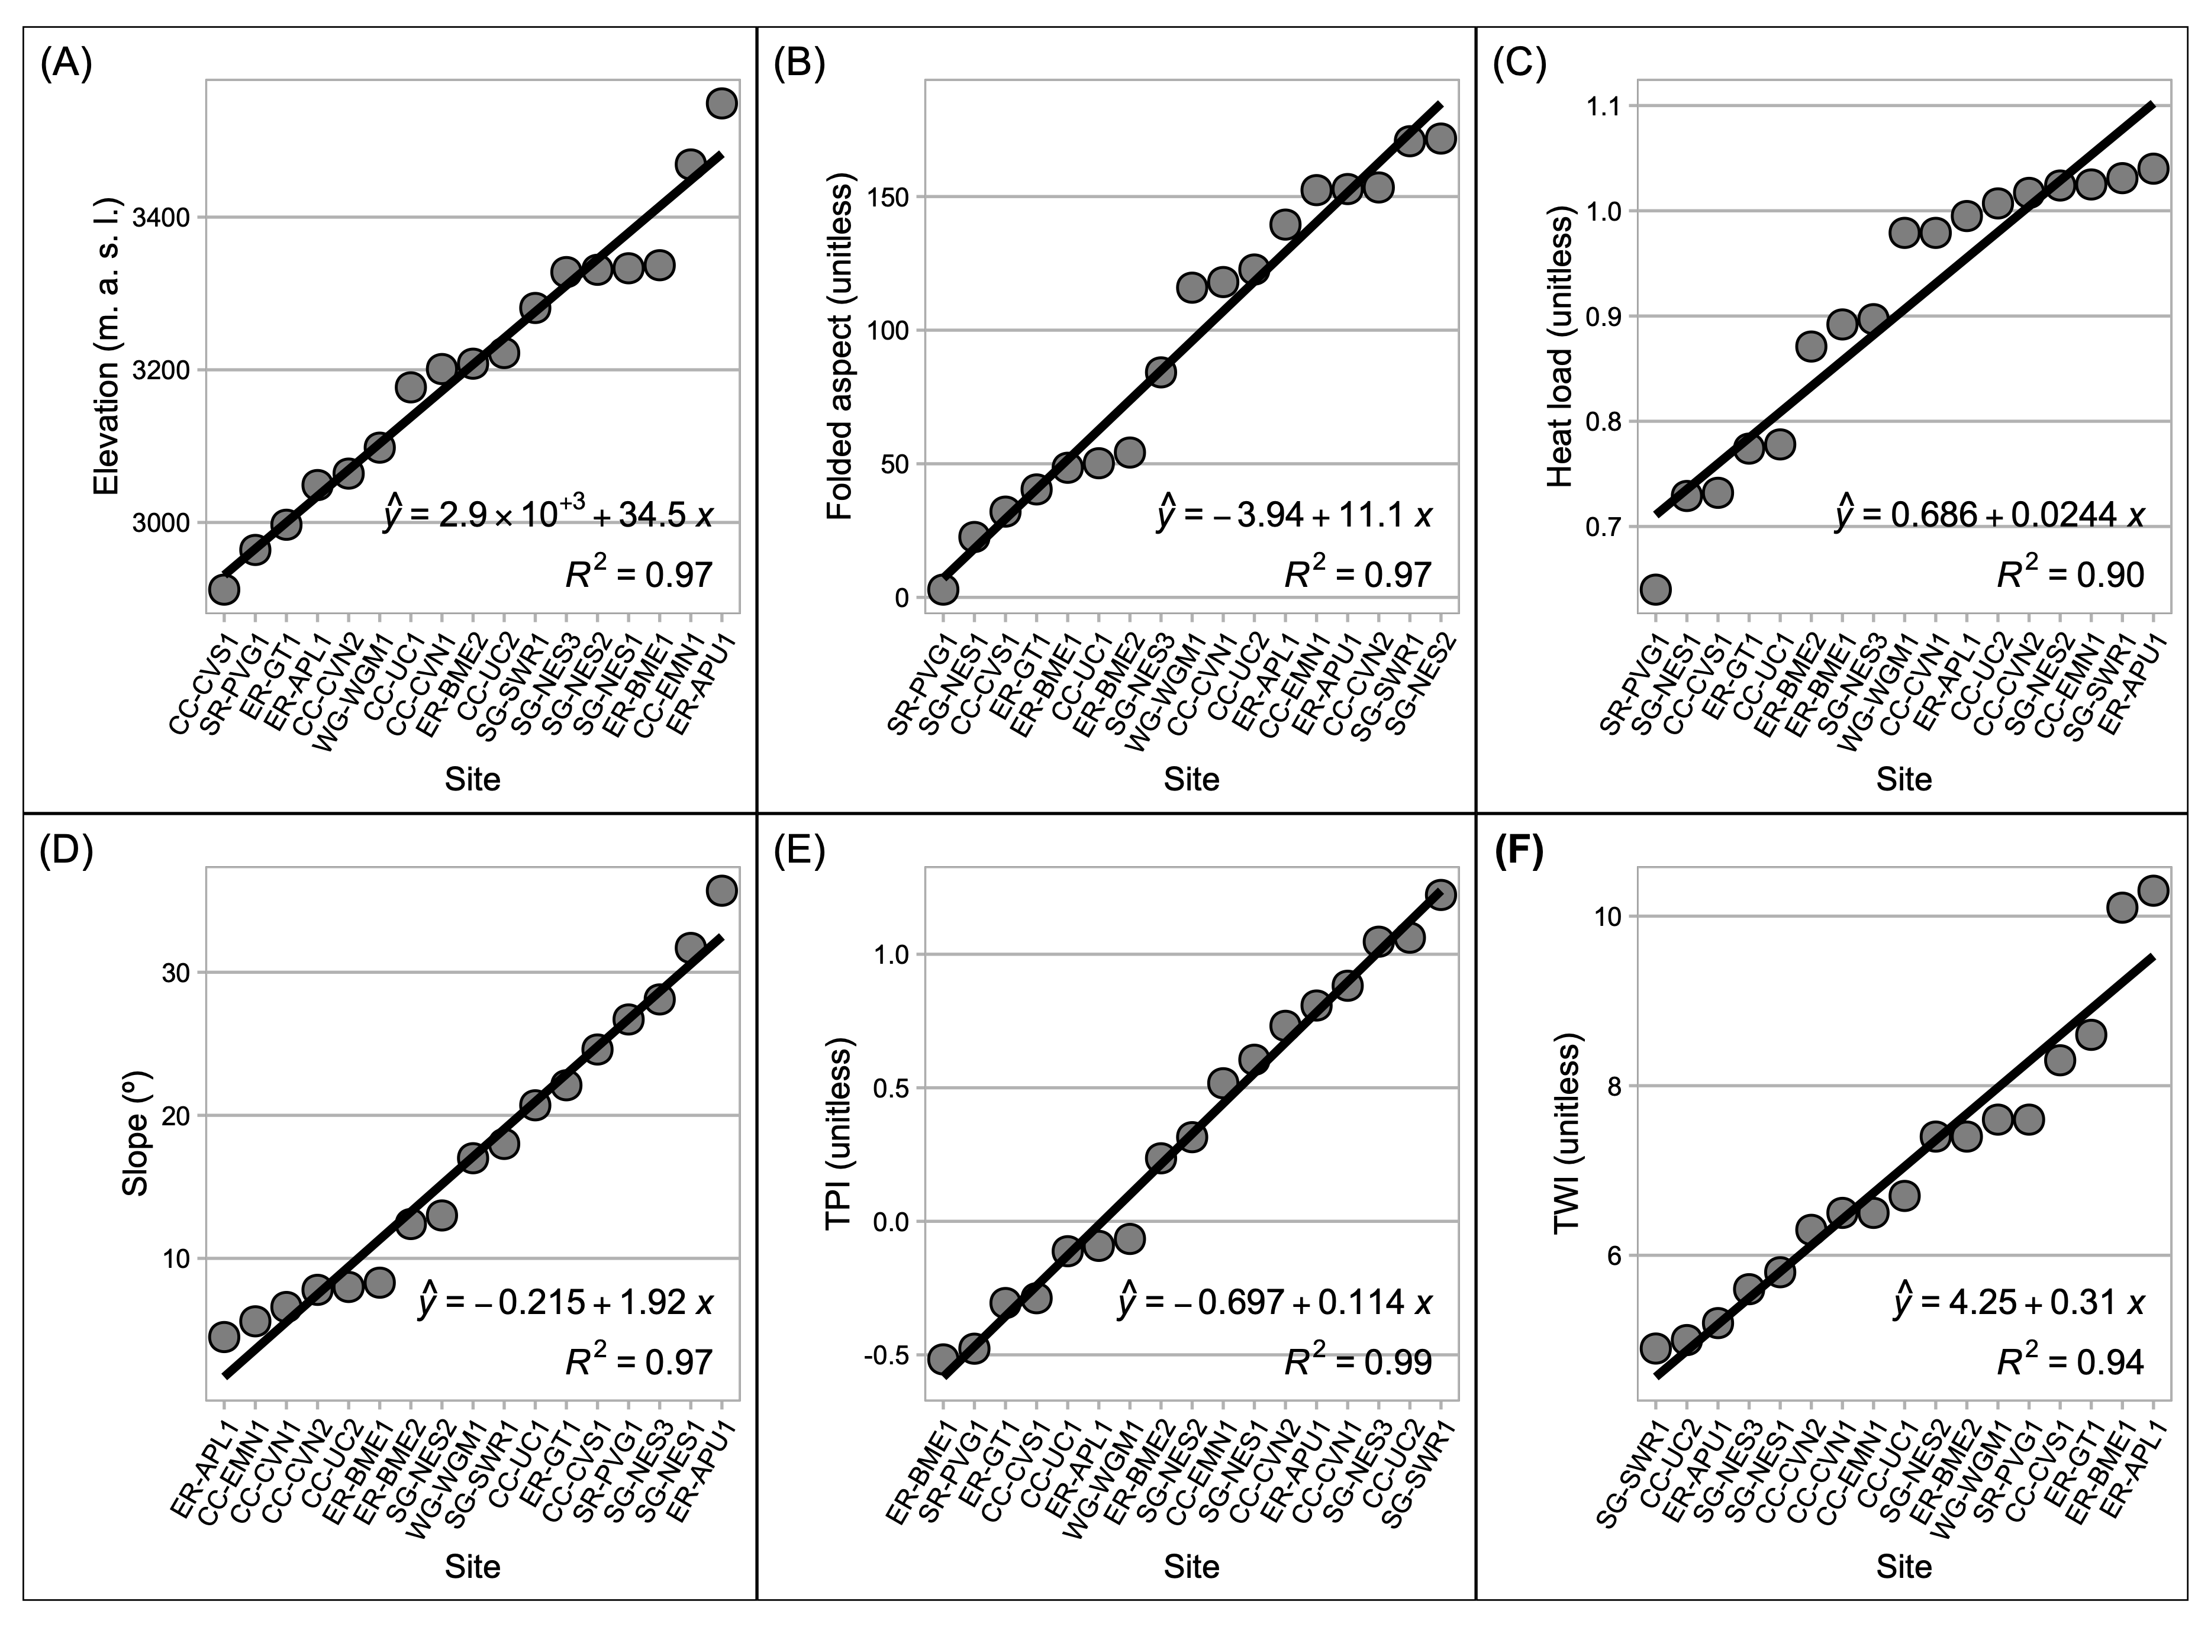 **Figure S1.** We selected inventory plot locations to capture six topographic gradients. We chose sites situated at the lowest and highest values of each gradient as they appear in the forested portions of the watershed and then optimized for an even distribution of sites between end-members. On this standard, a perfectly distributed set of sites would follow a straight line from the lowest to highest values with a slope equal to $\frac{max\left(value\right)−min\left(value\right)}{Nsites}$. Here, each facet depicts the distribution of sites along one of the topographic gradients as points, ordered from the lowest to the highest value. Solid lines are linear fits to the range of each topographic metric, and equations and R2 correspond to the fitted lines.

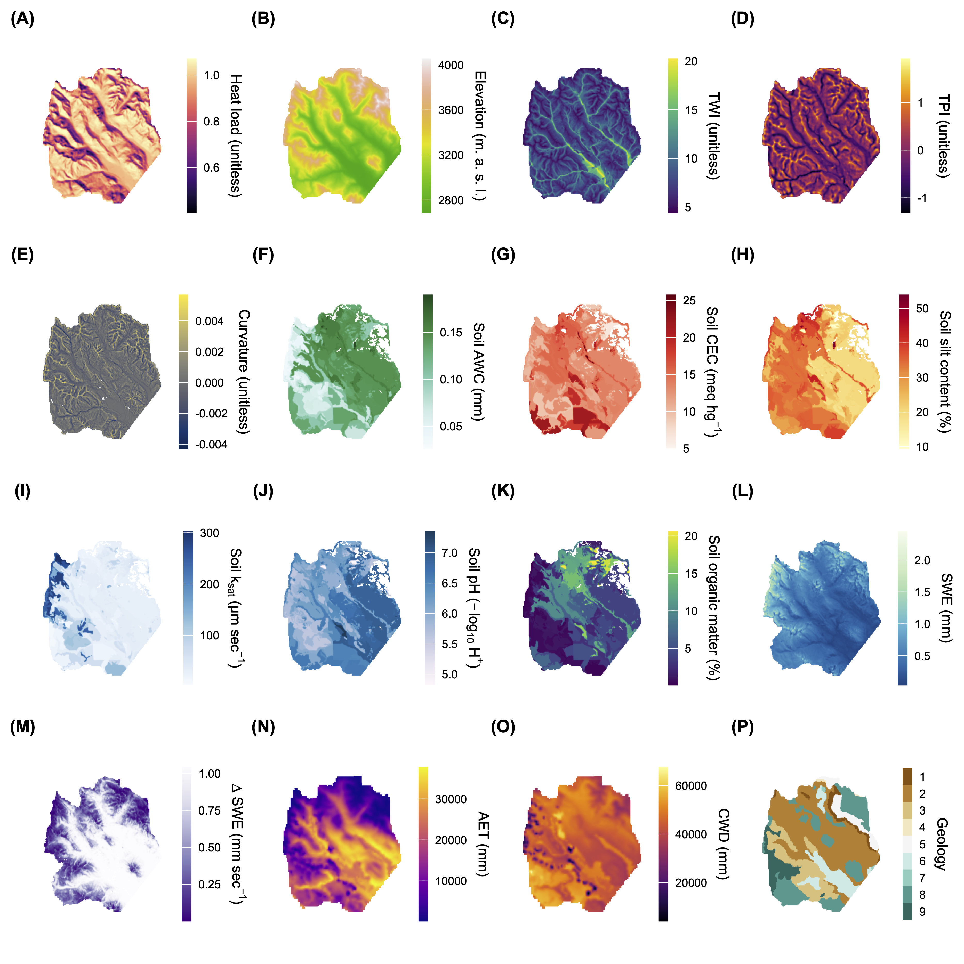 **Figure S2.** Raster images of abiotic explanatory variables. For Geology (P), the numeric scale [1-9] corresponds denotes the following lithologic groups: [1] Dakota Sandstone, [2] Mancos Shale, [3] Mesa Verde Formation (Sand/Silt/Coal), [4] Gothic Formation (Sand/Shale), [5] Maroon Formation (Red Sand/Mud/Conglomerate), [6] Glacial Drift, [7] Landslide Deposits, [8] Middle-Tertiary Granodioritic Laccoliths, [9] Wasatch Formation (Claystone-Shale).

**Figure S3.** To estimate DBH for each LiDAR-detected tree object, we used a simple linear model fit to DBH and height measurements from field inventory. We first split the raw DBH values into 1 cm DBH bins and then fit the function to the mean height and DBH in each bin. For error estimation we implemented a training and testing scheme with 80%-20% splits over 100 randomization folds. At each step, we fit model parameters to the training set and predicted $\hat{DBH}$ on the testing set using the fitted model scaled by its $σ^{2}/$. We computed the relative error (%) and RMSE between field-measured DBH and allometry-estimated DBH in the testing set at each step and averaged them. For an additional validation step, we predicted DBH on 800 out-of-sample inventory measurements on conifer trees in plots within the watershed that were not otherwise used in this analysis. Training-testing RMSE was 5.0 cm, and bias was 3.3%. On the out-of-sample validation set, RMSE was 5.4 cm, and mean validation bias was +17.8%. Fig. S3 shows the agreement between field-observed and allometry-estimated DBH values on out-of-sample validation data. Shading is by the number of observations (trees), and the diagonal line is 1:1.

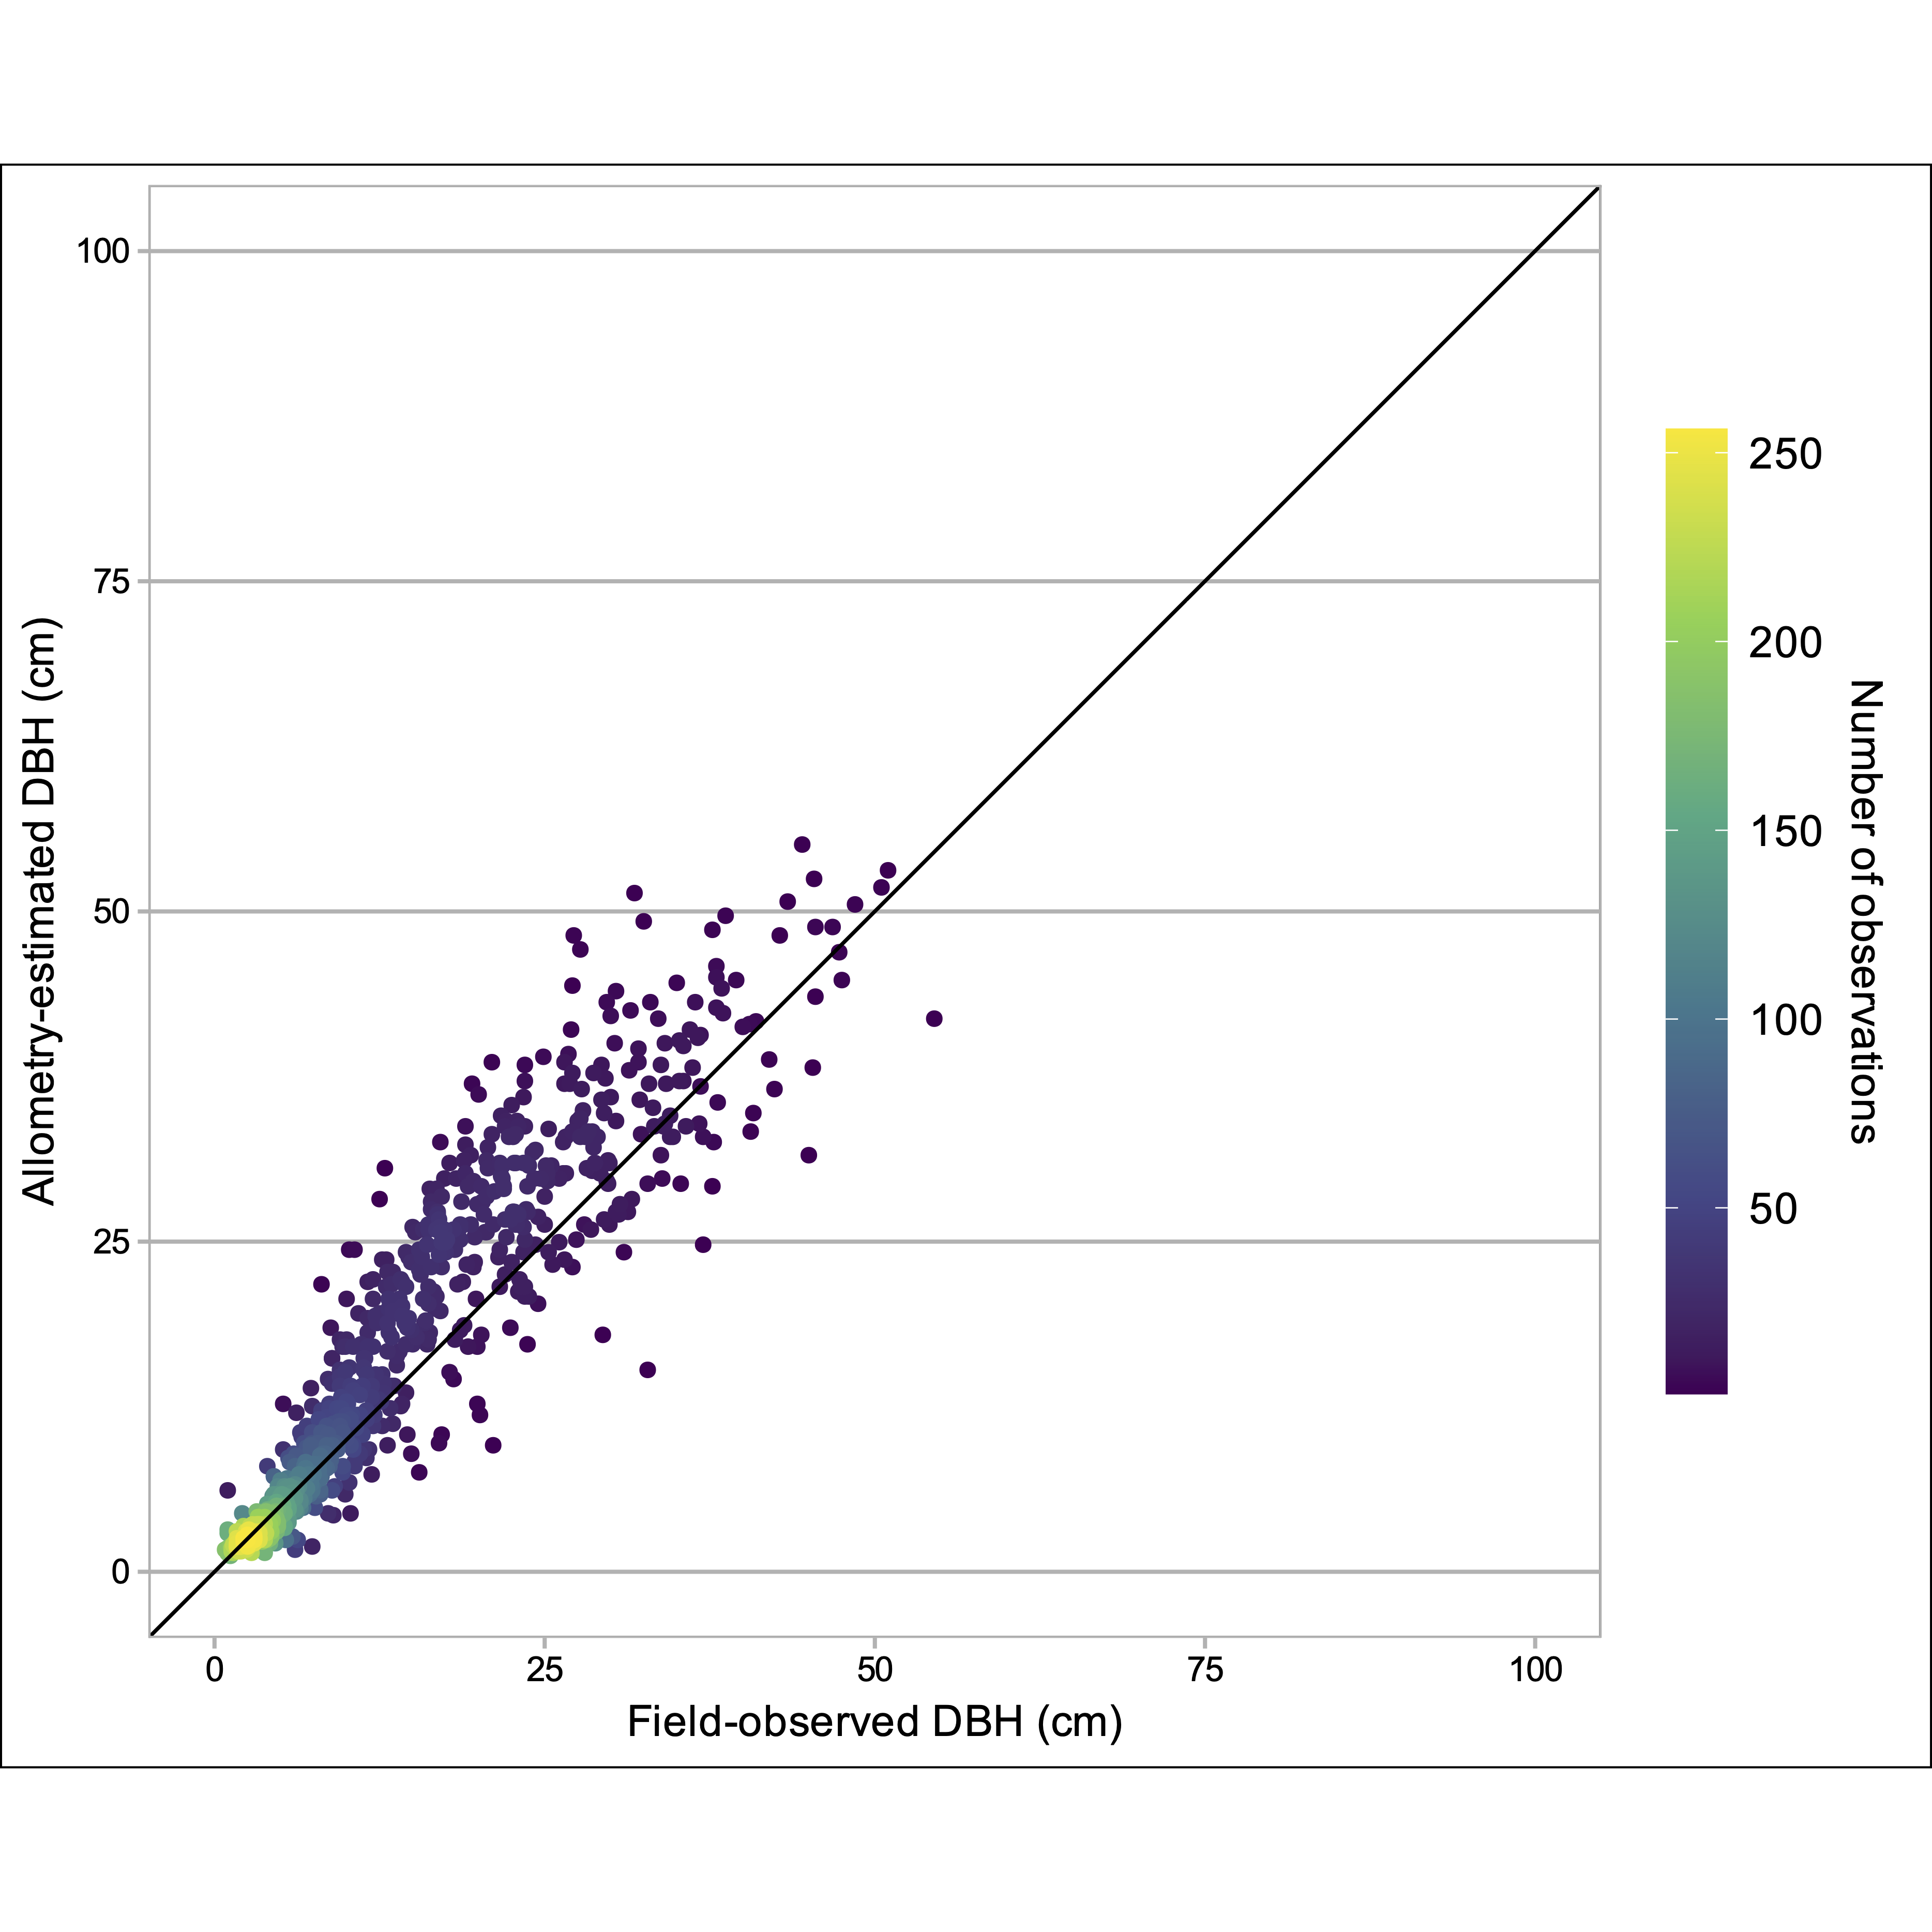

**Figure S4.** Partial-effects plots for all univariate explanatory variables in generalized additive models for each response (A-H).

